|  |
| --- |
| **NCSE303 - Software Project Management** |
| Project Documentation |
|  |
|  |
|  |
| **Stanley Masimba Chiremba 200180** |
|  |
|  |

**Project Name:** Online Library Management System



**Chapter 1: Project Definition**

1. **Introduction**

An online library management system (OLMS) is used to keep track of information on the books that are currently in the library, their authors, the library users who are issued books, the library staff, and other relevant details. It is really challenging to manually organize this and the manual upkeep of all this data is an extremely difficult operation. The development of technology has made it much easier to organize an online library. The Online Library Management system will be created to computerize, automate, and conduct all other processes related to member information, book issues, and book returns. The computerization of the library aids in many of its maintenance procedures. As the majority of the manual work is eliminated, the workload of management is decreased. To manage library books and users for this project, a web-based system will be employed. Because it was created utilizing web technologies, the system may be easily accessed by the institutions by being housed on the internet or an intranet.

1. **Background of The Study**

This project is built on the web development system. The researcher intends to use the website to create an online library management system. Every student is asking about their library status, specifically how many books they have checked out. Students have access to every element of life thanks to modern e-commerce systems. So, this technique is utilized in the industry to let students conveniently access the information they need regarding books.

1. **The Problem Statement**

The library’s issue is that they don't have a structured system in place to track and maintain their book inventory data. Because they only retain the inventory data in the logbook and are not properly structured, the librarian finds it challenging to record the data promptly and safely. Library management aims to reduce or eliminate all the problems brought about by the manual method of logbook library management. In many institutions of learning, library management has become a problem due to the continued use of manually supported systems (Burke, 2007). More than ten minutes are spent in line for students to borrow books from a librarian, who must physically register each student and the book they have borrowed. Due to a lack of suitable storage, some of these books are frequently never returned. Loss of priceless books and other academic materials that are crucial to library users occur as a result of the library's manual tracking system. This study is significant because of the apparent inefficiencies and the high labor costs associated with hiring multiple library aides.

1. **The Current System Description**

The current system in use is a manual library log book. Within this system, all library activities, including member registration, new book registration, book loaning out, etc., is conducted manually in a log book that is typically kept and managed by the librarian. Whenever a book is borrowed or returned, it is entered into a register in a non-computerized library management system, and then the status of the books is updated, all via pen and paper. A precise update of this data cannot be guaranteed because this process is lengthy. Books may be lost as a result of update process anomalies. As a result, libraries have a high demand for a more user-friendly interface that could immediately update the database, necessitating the necessity for this project.

1. **The Proposed System Description**

A software program called an online library management system enables you to correctly keep track of, control, and preserve books and book transactions. The planning, arranging, and tracking of book motions, lending, and return fulfillment are made easier by this e-library administration software. All of this is made possible by fusing a number of library book-related procedures and placing them at the librarian's fingertips on their computer. The librarian enters the information about the books into a central database using this system. As soon as a book is added to the system, the database is updated. This also happens when the book is being lent out, as well as when it is returned. to guarantee safety. There will be a sign-in page that makes it easier to log into the system and register new librarians who don't already have an account.

1. **The Objectives of The Proposed System**

* To create the best library management system possible that keeps track of all library file activity.
* To develop an adaptable system that reduces the issues with a conventional manual library system.
* To develop a user-friendly, cost-effective, and dependable electronic library management system.
* Control and performance improvement

1. **The Scope of Project**

Some libraries and educational institutions were studied and interviewed in order to determine what the Electronic Library Management System's requirements should be. Students and librarians both responded. Internet, books, and respondents served as the data sources. An Electronic Library Management System, which will automate the main library functions, is the project's final output. To keep track of the system's permitted users, the initial subsystem is the registration and logging in of users. The second subsystem tracks when new books are introduced into the library by registering them in the library management system. The user's primary area of need is the third subsystem, which is a borrower and return of books.

**Chapter 2: Feasibility Study**

1. **Project Plan (Gantt Chart)**
2. **Introduction**

In Chapter 2, the greySense library management system is investigated and appraised. We look into the suggested idea's potential. This chapter will focus on the advantages of the new system and the drawbacks of the existing system to determine whether it will be a viable alternative for libraries, their staff, and the environment in which they operate.

1. **Existing System Summary and Problems**

Currently, a manual library log book is being used as the system. All library operations in this system, such as member registration, new book registration, book loaning out, etc., are manually carried out in a log book that is normally maintained and overseen by the librarian. In a manual, non-computerized library management system, each time a book is checked out or checked back in, the information is entered into a register and the status of the books is updated. The lengthy nature of this operation prevents a precise updating of this data from being guaranteed. Anomalies in the update process could result in the loss of books. This is necessary because libraries have a high demand for a more user-friendly interface that could instantly update the database.

**Problems**

* It is impossible to generate reports quickly.
* Tracing a book is challenging.
* The scenario does not allow for a speedier inquiry.
* The main obstacle is trying to look for old records.
* A complex system is required to preserve the enormous volume of publications.
* It takes time.
* Paper-based systems make it difficult to send reports to management in a flexible manner.

1. **Benefits of The Proposed System**

* Simple book control and management
* There are no worries regarding book levels causing under- or overstocking.
* Cost savings for all levels of book inventory
* Assist you in removing the risk of lost or returned borrowed books
* Boost employee effectiveness

1. **Technical Feasibility**

**Hardware Requirements**

**WIFI or alternative Internet Connectivity**

For the librarian to access the online library management system website.

**Computer/Laptop**

For the librarian to access the e-library management system website.

**Software Requirements**

**XAMPP Server**

We'll use this relational database management system for data entry and storage. It will be linked to the code and provide a quick and easy way to build databases.

**Adobe Dreamweaver & Visual Studio Code**

These programs will be needed for the creation of the actual website.

**System development tools**

* **HTML**

The markup language HTML5 is used to organize and present content on the Internet. It is the World Wide Web Consortium's fifth and last major recommendation for HTML. The HTML Living Standard is the name given to the current specification.

* **CSS**

Cascading Style Sheets is a language for creating style sheets that describe how a document presented in a markup language, such HTML or XML. Along with HTML and JavaScript, CSS is a key component of the World Wide Web.

* **JavaScript**

Along with HTML and CSS, the computer language known as JavaScript, or JS, is one of the foundational elements of the World Wide Web. 98% of websites will use JavaScript for client-side webpage behavior by the year 2022, frequently incorporating third-party libraries.

* **PHP**

A general-purpose programming language designed specifically for web development is PHP. It is applied to the creation of interactive and dynamic websites. It was one of the first server-side languages that HTML could incorporate, making it simpler to add functionality without having to call outside files for information.

1. **Operational Feasibility (Does it meet expectations)**

Operational feasibility examines a system's suitability for use in a certain setting. This online library book management system offers several features that make it practical to use. Any user with basic computer abilities can utilize the system because it is simple to use and navigate. It made use of security tools and access controls that restrict login access to just authenticated persons. The system is easy to use because it gave users a variety of options to choose from and carry out their tasks. It offers a simpler method of obtaining user input for later processing. It is not necessary for end users to be technically skilled to use the system.

1. **Social Feasibility**

The worry of job loss that comes with computerization is common among the current workforce. Automation of a library won't increase unemployment; instead, it will lead to the creation of new jobs such as system manager, system analyst, programmers and personnel responsible for maintaining programs, data input operators, etc. Additionally, it will free up the existing professional staff from their mundane administrative tasks so they may focus on intellectual professional tasks that call for staff rearrangement. Professional personnel will be reorganized, which will improve jobs and increase job satisfaction.

1. **Schedule Feasibility**

The “Project Plan” sub-section contains a detailed schedule for the system's development. The realistic timetable shows that the system development can be completed within the targeted time range.

1. **Legal Feasibility**

Since this system was created utilizing open source software, there aren't many license concerns. The laws and regulations governing the operation of the institution are applicable to this system because it was designed to work in a library.

1. **Economic Feasibility**

The running costs of the system are compared to the revenue and total returns in this feasibility study. This online library book management system is economically viable in that it is less expensive to buy, uses less paper because it operated automatically, requires fewer personnel, which ultimately results in lower operating costs, and saves users' time by facilitating faster services.

1. **Conclusion and Recommendations**

The system is intended to be used by library employees for inventory purposes. It is practical both legally and economically, as well as socially acceptable. Any worried libraries looking for useful technologies to make library management simpler for their businesses are offered the researcher's solution, greySense e-Library, by the researcher

**Chapter 3: Analysis**

1. **Existing system – Description and Problems**

Currently, a manual library log book is being used as the system. All library operations in this system, such as member registration, new book registration, book loaning out, etc., are manually carried out in a log book that is normally maintained and overseen by the librarian. In a manual, non-computerized library management system, each time a book is checked out or checked back in, the information is entered into a register and the status of the books is updated. The lengthy nature of this operation prevents a precise updating of this data from being guaranteed. Anomalies in the update process could result in the loss of books. This is necessary because libraries have a high demand for a more user-friendly interface that could instantly update the database.

**Problems**

* It is impossible to generate reports quickly.
* Tracing a book is challenging.
* The scenario does not allow for a speedier inquiry.
* The main obstacle is trying to look for old records.
* A complex system is required to preserve the enormous volume of publications.
* It takes time.
* Paper-based systems make it difficult to send reports to management in a flexible manner.

1. **Data gathering techniques used**

* Interview
* Questionnaires and surveys
* Discussions in focus groups
* Observation

1. **User requirements**
2. **Functional Requirements**

**User Login**

The user logs in to the system using this feature. They must provide their login ID and before they may access the system, their user id and password will be checked and the user is permitted to refrain from entering the system if there is an invalid ID. Only users with valid IDs and passwords should be able to access the system. When a user is done using the system, they must be able to log out.

**User Sign Up**

All users have access to this function, which allows them to create accounts for new users. Information must be able to be verified by the system, and if it is incorrect, information must be able to be deleted.

**Add New Book**

New books can be added to the library using this function. System must be able to validate the book's information. Two books with the same book ID must not be permitted by the system.

**Delete Book**

Existing books in the database can be removed from the library using this function. System must be able to validate the book's information. The system should be able to successfully delete a book from the database.

**Search for a book**

The book maintenance section contains this function. We can conduct a book search using the book's ID, title, author, or publishing. The database must be searchable by the system using a chosen search type. It is necessary for the system to display the filtered book in table view.

**Search for a student**

The student maintenance section contains this function. We can conduct a student search using the student’s ID, title, author, or publishing. The database must be searchable by the system using a chosen search type. It is necessary for the system to display the filtered student in table view.

**Record Book Check Out**

This function is executed when a student borrows a book from the school library. The book information is noted, as well as crucial information about the student who borrowed it. The process is simplified as there is a date picker option for selecting when exactly the book was taken.

**Record Book Check In**

This function is executed when a student returns a book to the school library. The book information is noted, as well as crucial information about the student who borrowed it. The process is simplified as there is a date picker option for selecting when exactly the book was returned.

1. **Non-Functional Requirements**

**Efficiency**

When a library management system is built, librarians and users will have easy access to the library because searching and purchasing books will be completed much more quickly.

**Reliability**

The system's member registration, member validation, report creation, book transaction, and search functions should be executed precisely.

**Usability**

The system is made to be user-friendly so that library personnel and students can do the various duties quickly and efficiently.

1. **Alternative Solutions**

* Collect opinions from all parties involved.
* enlist the assistance of all those who are impacted to seek recognition or agreement.
* establish ongoing oversight and controls
* Assess the long-term outcomes only based on the final response.

1. **Chosen/Recommended solution**

Collect opinions from all parties involved.

1. **Evaluation of Ethical considerations**

* respect individuals' privacy
* preserve anonymity
* just focus on important components
* Avoid harm

**Chapter 4: System modelling**

1. **UML diagrams/ Use case diagrams ERD/ DB schema/ Class diagrams**

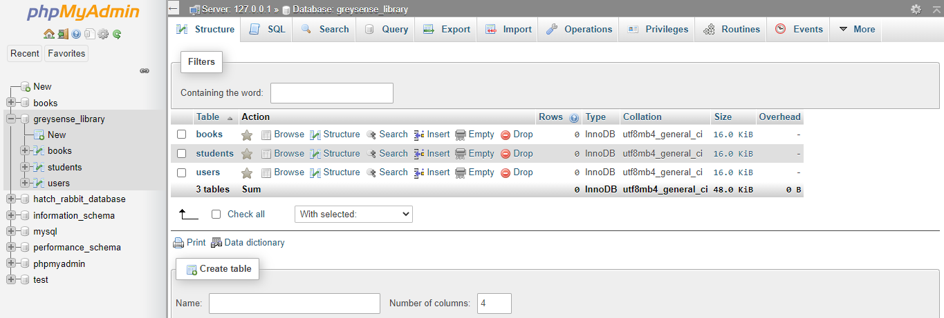**Database Design for System**

Figure Database design for system

**Students Table**

**User Table** 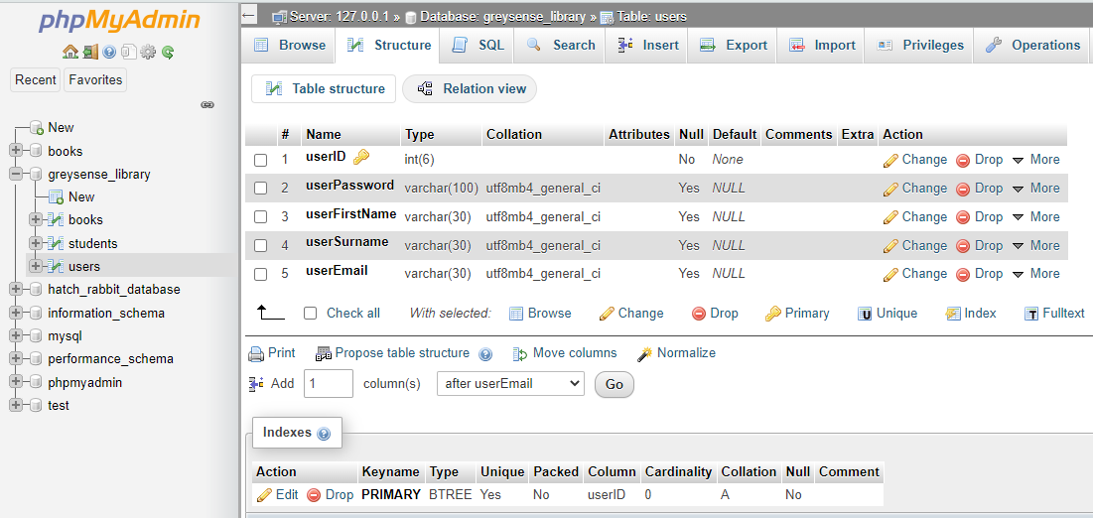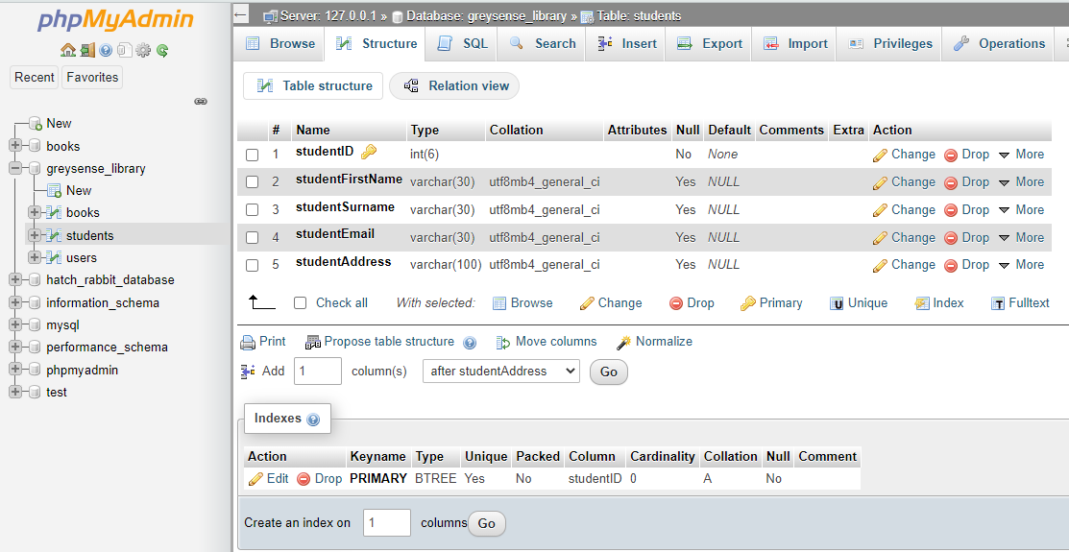

Figure Users Table

Figure Students Table

**Books Table**

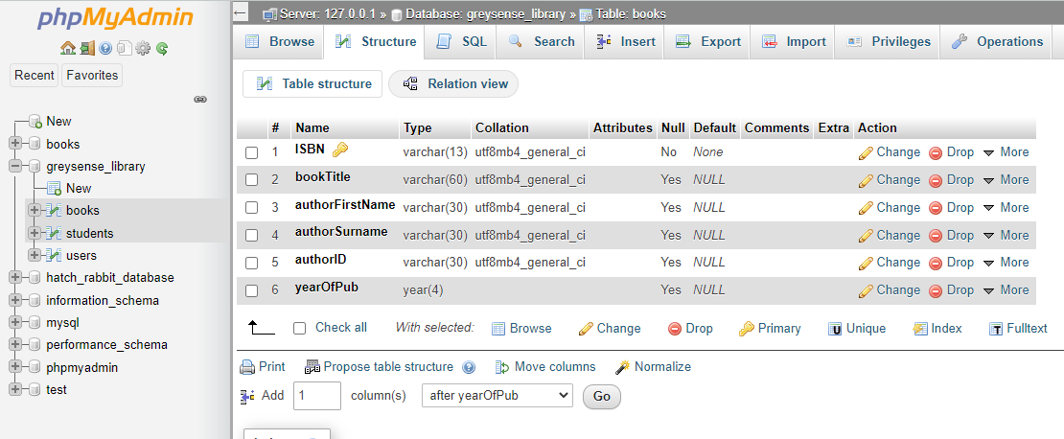

Figure Books Table

‘

**Data Flow Diagram**

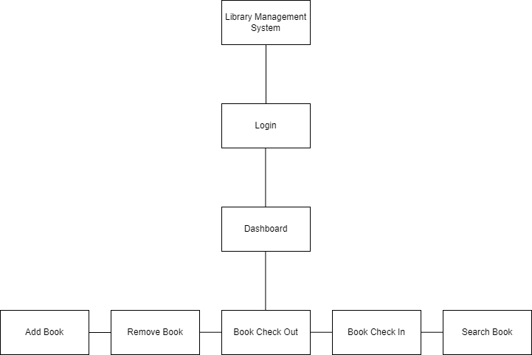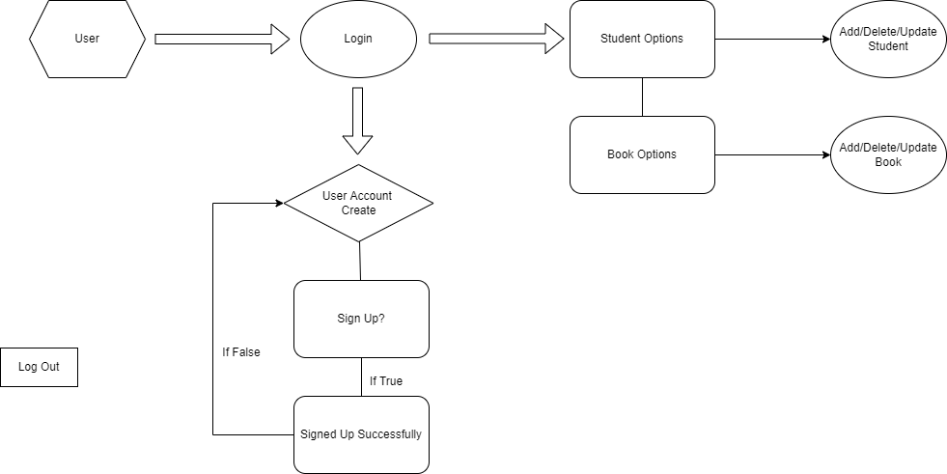

Figure Data Flow Diagram

**Modular Design**

Figure Modular Design

**System Class Diagram**

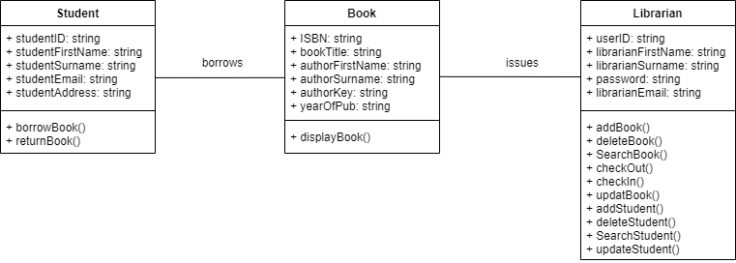

Figure System Class Diagram

**Entity Relationship Diagram**

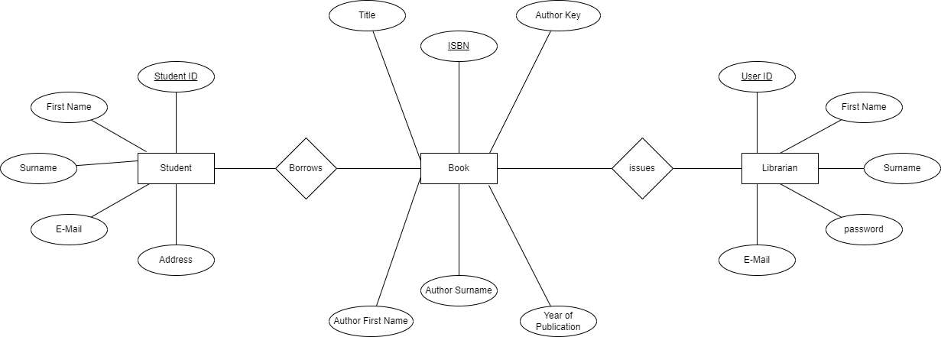

Figure Entity Relationship Diagram

**System Use Case Diagram** 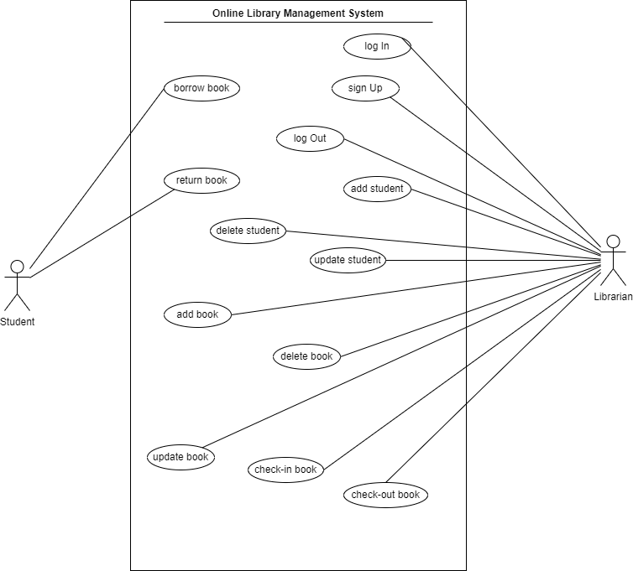

Figure System Use Case Diagram

**Chapter 5: System design**

1. **Interface design**

**Home Page**

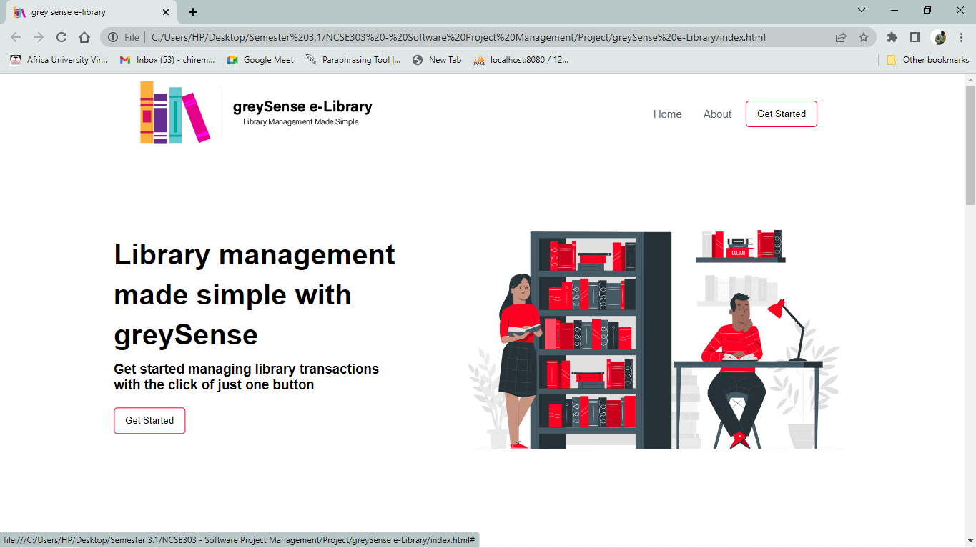

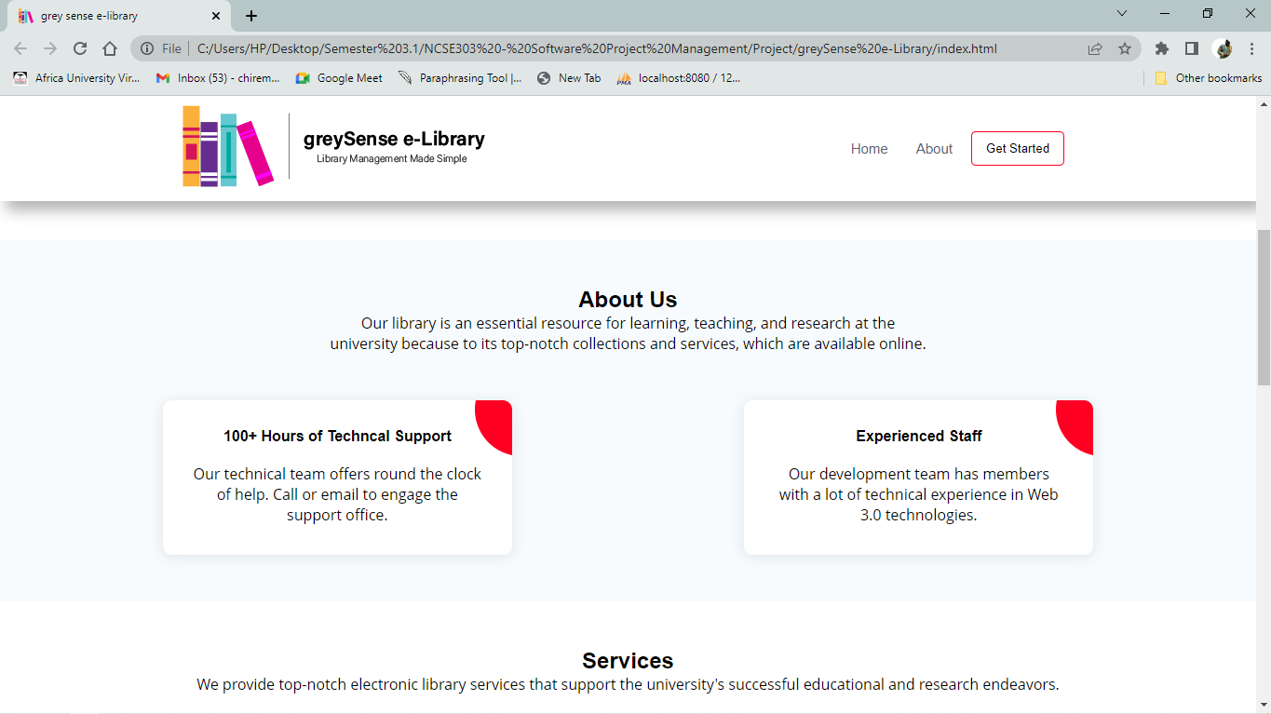

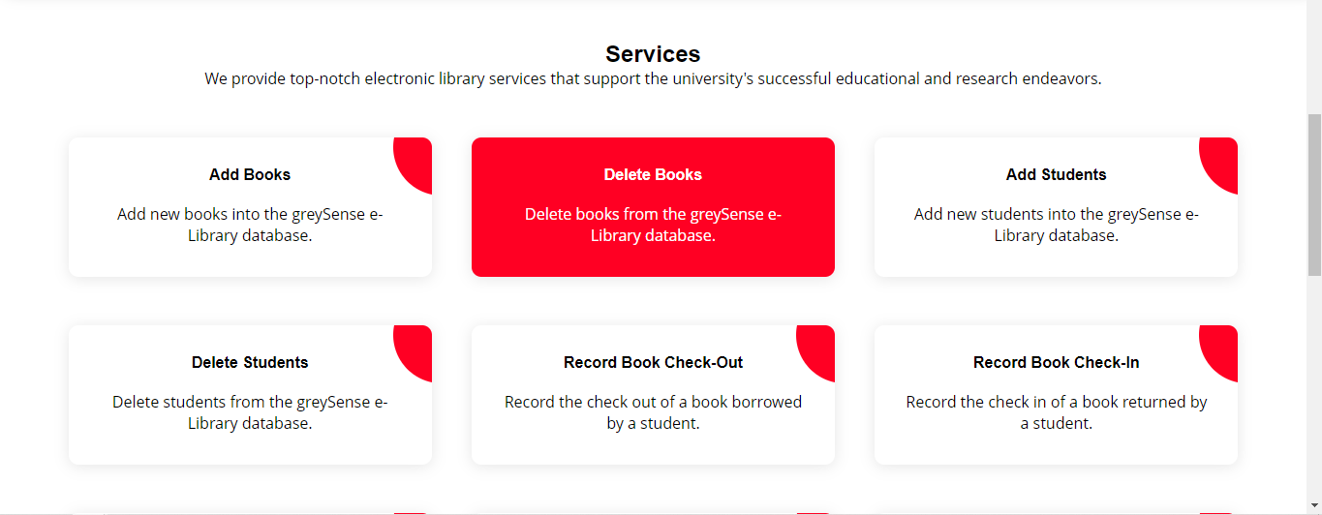

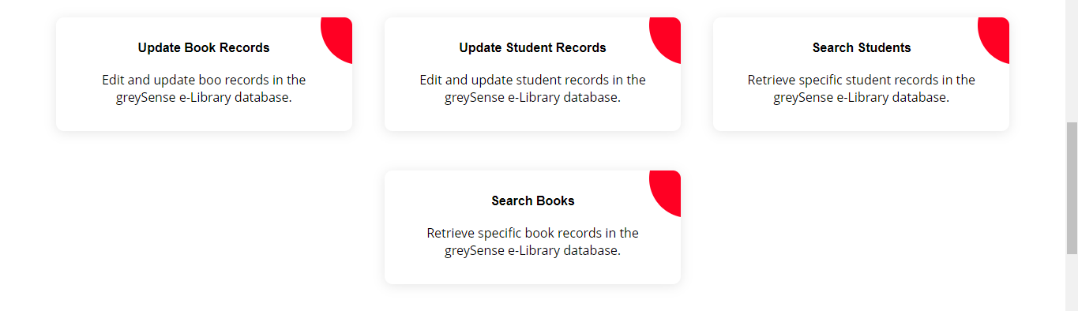



Figure Complete Vertical Home Page

**About Us Page**

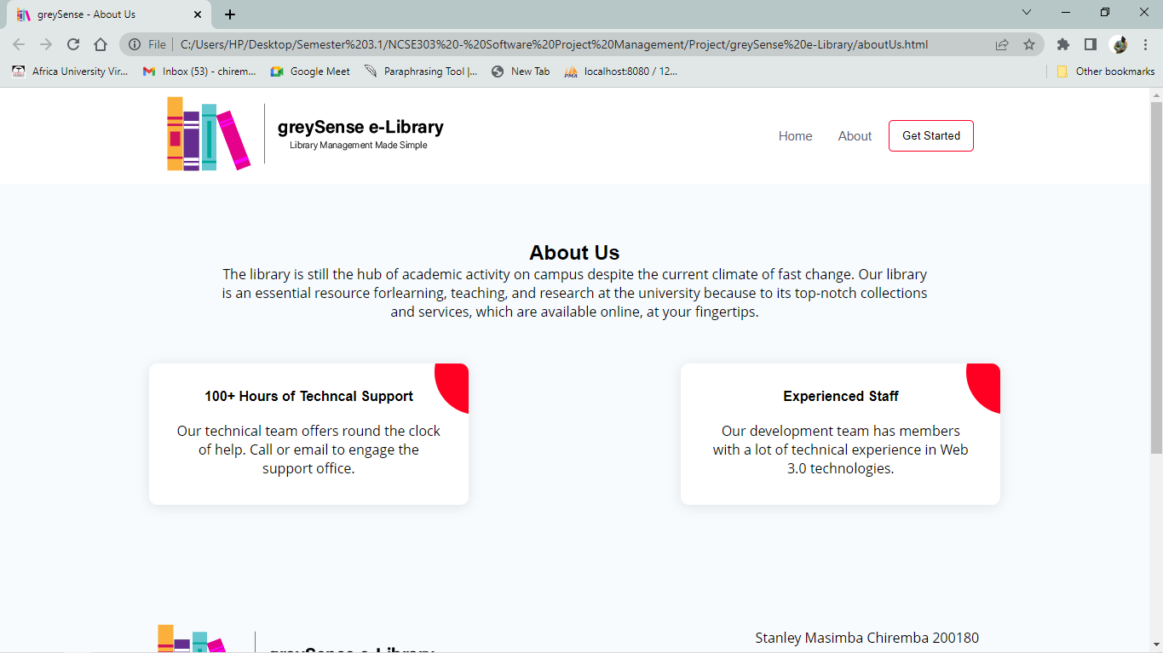

Figure About Us Page

**Add Book Page**

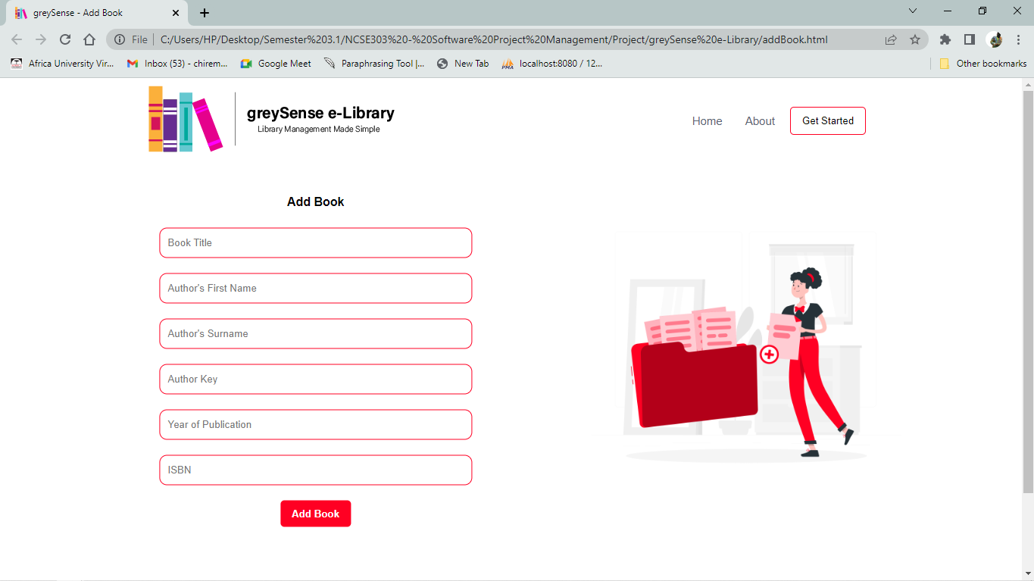

Figure Add Book Page

**Add Student Page**

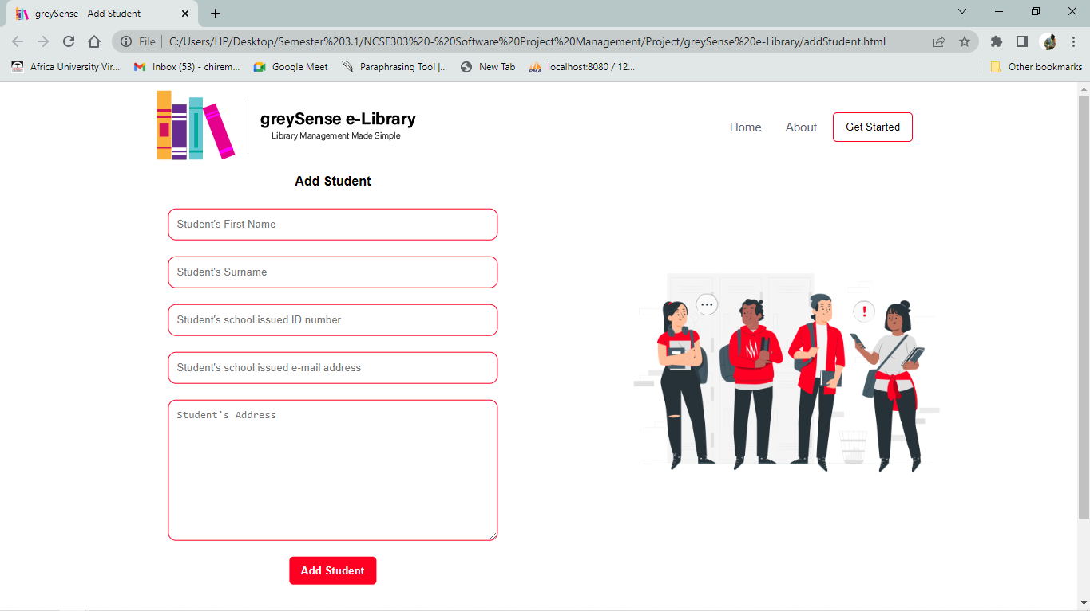

Figure Add Student Page

**Book Check In**

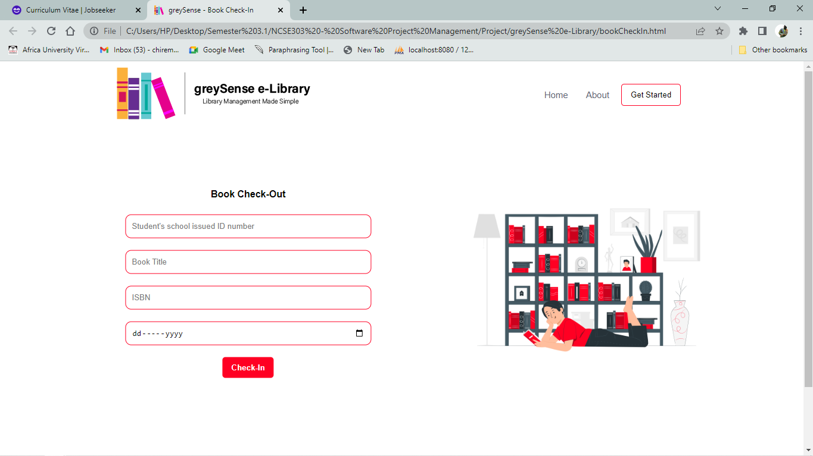

Figure Book Check In

**Book Check Out**

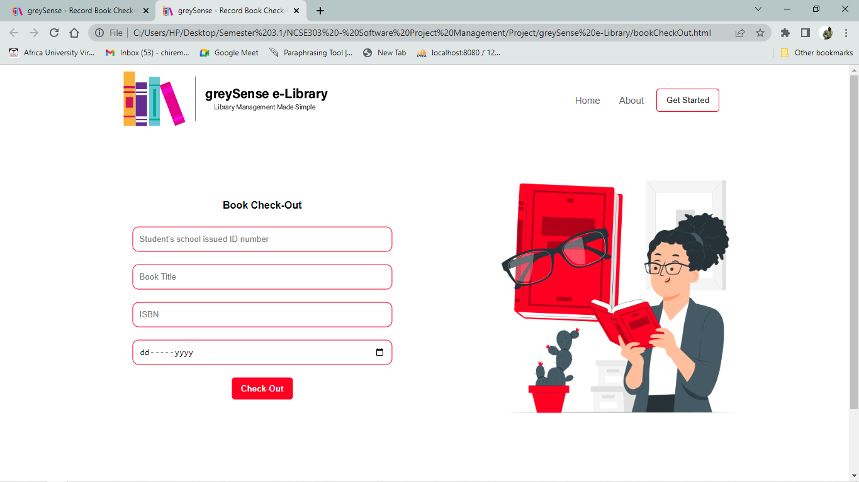

Figure Book Check Out

**Log In**

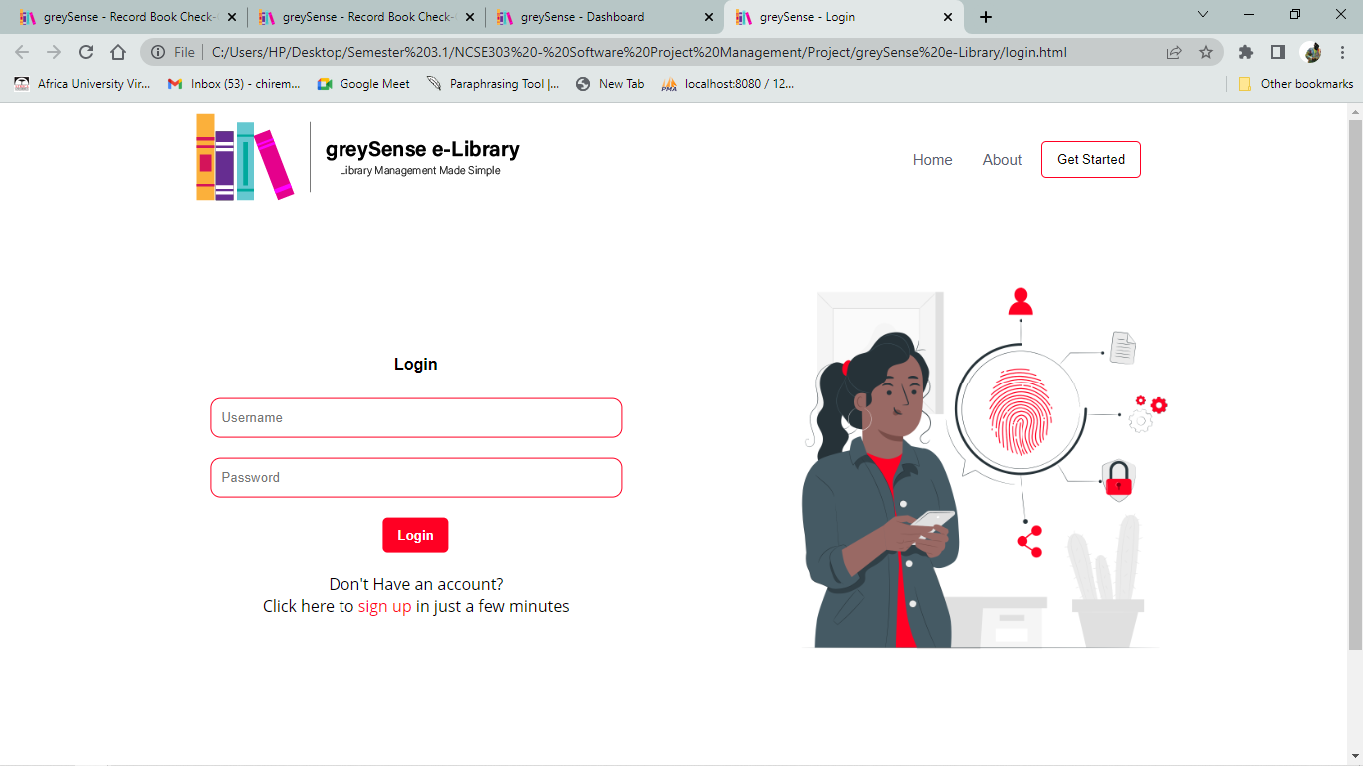

Figure Log-In Page

**Sign Up**

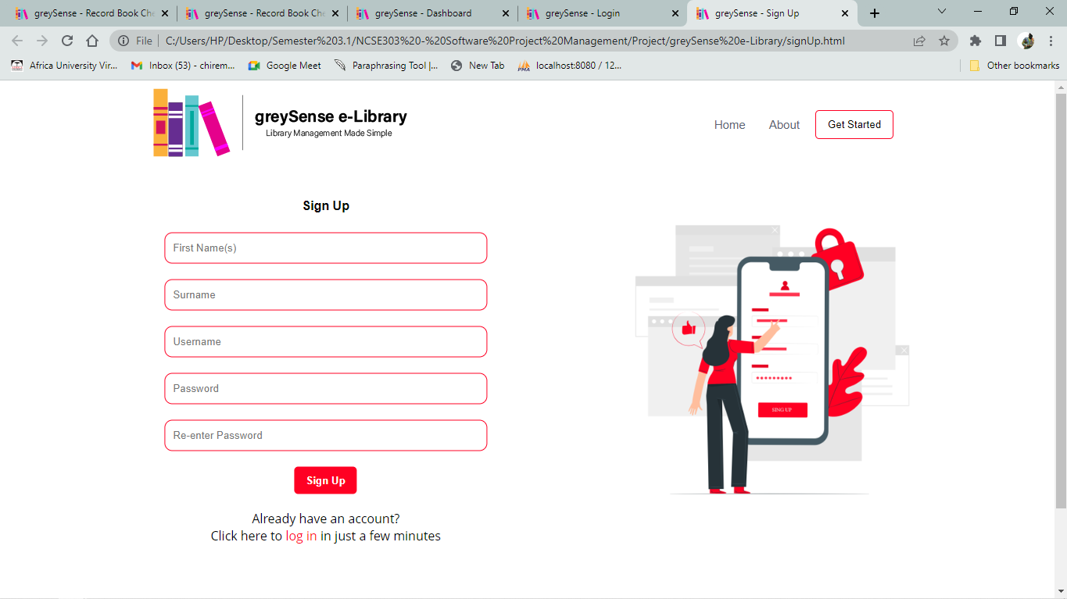

Figure Sign Up

**Dashboard Page**

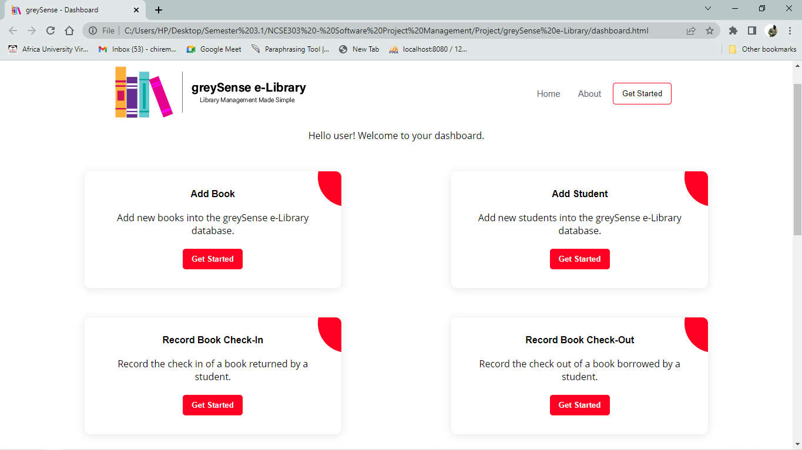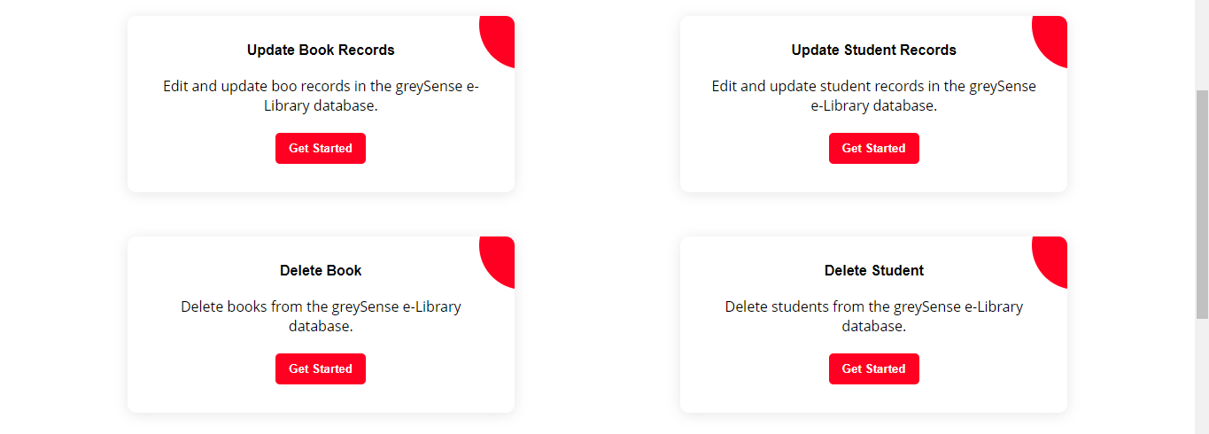

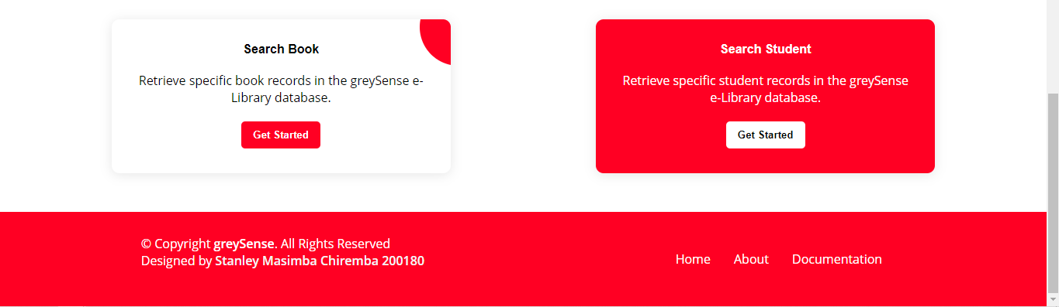

Figure Vertical View of Dashboard Menu Page

**Update Book**

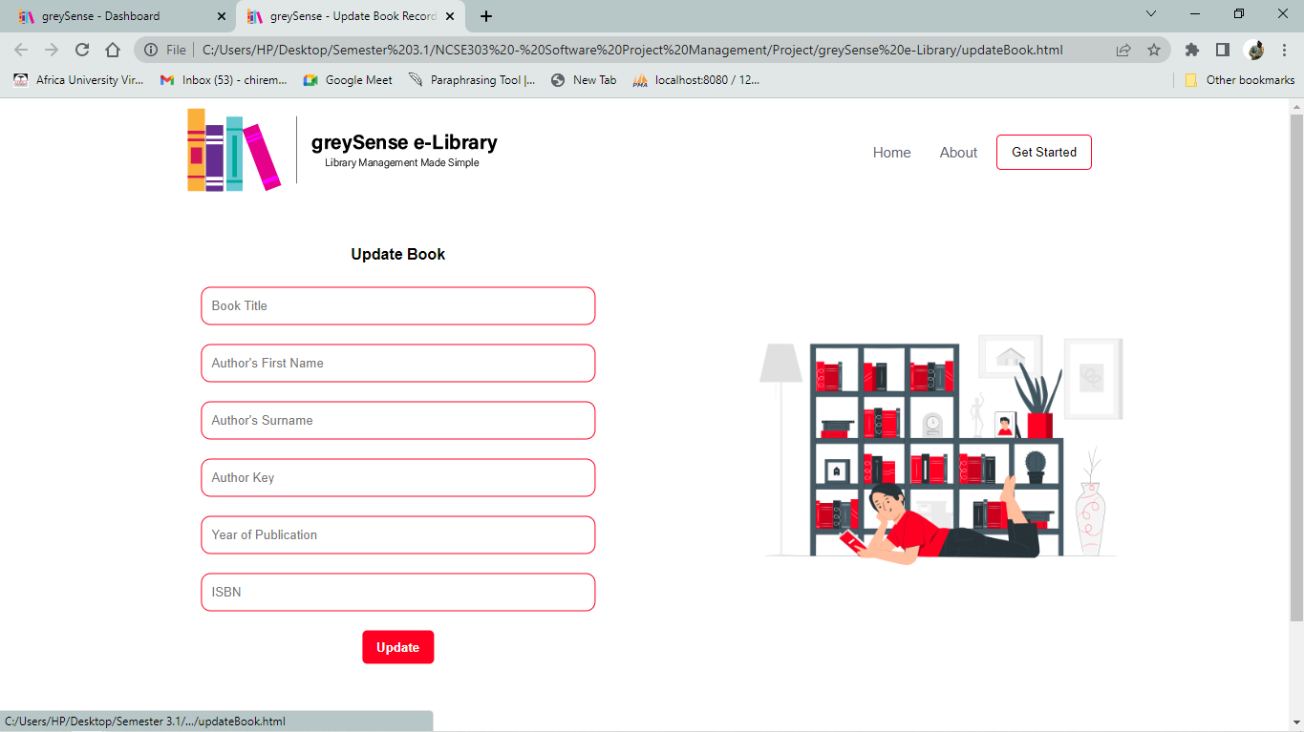

Figure Update Book Page

**Update Student Info**

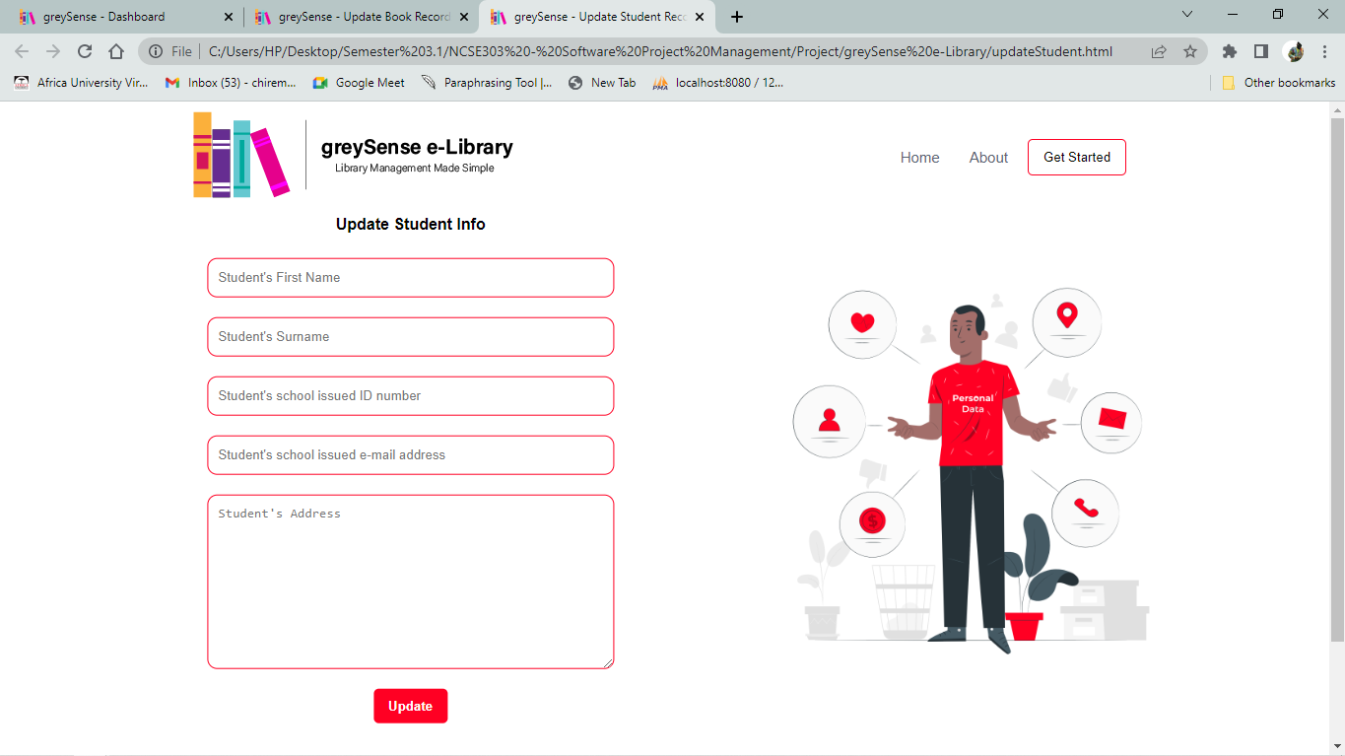

Figure Update Student Info

1. **Menu design**



1. **System architecture**

The current system is built on the basis of MySQL database, HTML, CSS, JavaScript and PHP programming languages. In MySQL, facilitated by XAMPP Server, the database keeps all relevant information for the books, librarians and students. Different tables are created to retrieve and store the entity data needed for the system to operate. The concept of primary keys and foreign keys facilitates the connection on the different tables, in order for actions like recording a student borrowing a book to be done.

**Database**



Figure greySense e-Library Database

**Students Table**



Figure Students Table

**Books Table**



Figure Books Table

**Users Table**



Figure Users Table

1. **Module design**



Figure Module Design

The online Library Management System is modularized into a number of components, with each component having its own interface in which a number of functions are present. The system has accessibility rights to gain and control access to the different modules once the user is logged in.

**Login Module**

The user logs in to the system using this feature. They must provide their login ID and before they may access the system, their user id and password will be checked and the user is permitted to refrain from entering the system if there is an invalid ID. Only users with valid IDs and passwords should be able to access the system. When a user is done using the system, they must be able to log out.

**User Sign Up Module**

All users have access to this function, which allows them to create accounts for new users. Information must be able to be verified by the system, and if it is incorrect, information must be able to be deleted.

**Add New Book Module**

New books can be added to the library using this function. System must be able to validate the book's information. Two books with the same book ID must not be permitted by the system.

**Delete Book Module**

Existing books in the database can be removed from the library using this function. System must be able to validate the book's information. The system should be able to successfully delete a book from the database.

**Search for a book Module**

The book maintenance section contains this function. We can conduct a book search using the book's ID, title, author, or publishing. The database must be searchable by the system using a chosen search type. It is necessary for the system to display the filtered book in table view.

**Search for a student Module**

The student maintenance section contains this function. We can conduct a student search using the student’s ID, title, author, or publishing. The database must be searchable by the system using a chosen search type. It is necessary for the system to display the filtered student in table view.

**Record Book Check Out Module**

This function is executed when a student borrows a book from the school library. The book information is noted, as well as crucial information about the student who borrowed it. The process is simplified as there is a date picker option for selecting when exactly the book was taken.

**Record Book Check-in Module**

This function is executed when a student returns a book to the school library. The book information is noted, as well as crucial information about the student who borrowed it. The process is simplified as there is a date picker option for selecting when exactly the book was returned.

1. **Security and control**

For the system’s security and control features, the website has a login page present for the librarians to sign into their library management accounts, and restrict just anyone from accessing the system. Complementary to this, if the user has no account, they have the option to sign up and create one, allowing them to then log in. The password fields are visually hashed with Asterix (*) to ensure no one can see it, if they were to look at the screen as the login credentials are keyed in.

Additionally, the form’s input fields are to be validated by JavaScript data validation functions to ensure that the data is in correct formats, as well as ensuring that no compulsory field is left unfilled. Either intentionally or by user error.

**Chapter 6: Implementation**

1. **System flow chart**

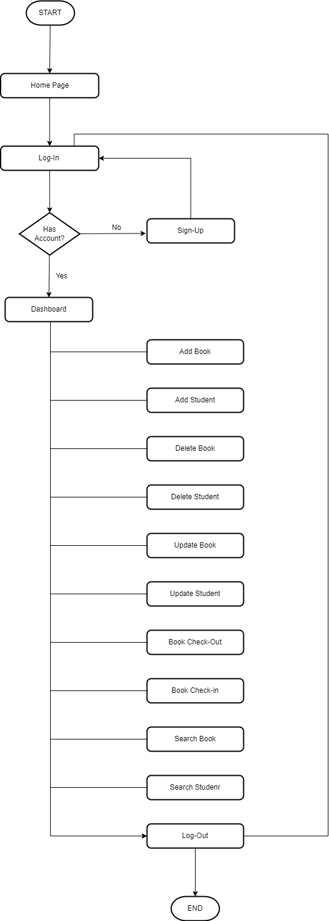

Figure System Flowchart

1. **Program flowchart**

**Login Page**

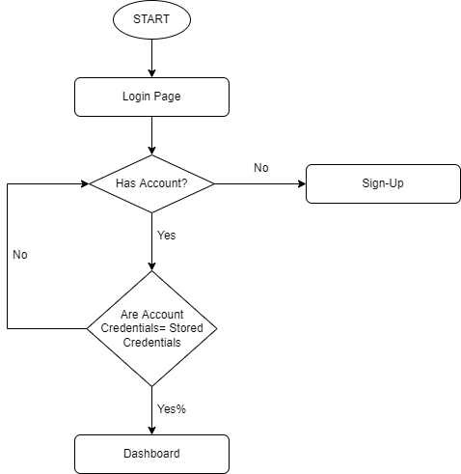

Figure Log-In Flowchart

**Add Book Flowchart**

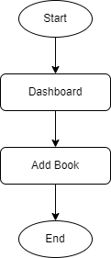

Figure Add Book Flowchart

1. **Code/working system**

**Chapter 7: Testing**

1. **Test cases (include all possible test cases)**
2. **Test results**
3. **Unit/black box testing**
4. **User Acceptance testing**

**Chapter 8: Deployment**

1. **Deliverable product/ client site installation**
2. **User manual**
3. **Maintenance and review plan**
4. **Conclusion**